Nathan Gillispie

Studying Electric Fields With Cenco Overbeck Apparati and Computer Simulation.

Lab Partner: Luke Alford

Date of experiment: September 1, 2022

# Abstract:

Using a digital multimeter, Cenco Overbeck apparatus and power supply, we reconstruct the electric field lines from the gradient of the equipotential lines in the apparatus. From there, we calculate the force of the electric field at some arbitrary points. A simulation of the electric field lines is created using Excel and the results are found to be visually similar showing that our mathematical basis for electric fields works.

# Introduction:

Electric fields exist; however, they are not usually visible. Since the electromagnetic force is such an integral part of physics curriculum, the intuition and visual aid of electric fields can greatly help students grasp the concept. A relatively straightforward device is the Cenco Overbeck apparatus. This device consists of a silver-plated graphite sheet. Typically, two silver conductors are spaced apart and in interesting design. Our designs tested were point-point, point-plate, and plate-plate. A circuit is made with the power supply and conductors and a digital multimeter is connected to a probe. The probe is two sided and allows the user to draw on a piece of paper above at the exact point the contactor below is touching the graphite or conductor. The multimeter circuit is completed by attaching ground to a conductor on the apparatus. When the voltage on the supply is set to 10V, one conductor will read exactly 0V and the other 10V.

We cannot measure the electric fields directly, but we can measure the voltage at a specific point. It turns out that we can indirectly find the electric field vector at a point by finding the direction of “steepest descent” in voltage. This is because the electric field goes from higher to lower voltage given ground is 0. Mathematically we can write the electric field using the gradient operator on the voltage at a point:

Equation : The connection between electric fields and potentials.

We can also use limit notation where is the unit vector in direction of steepest ascent in voltage. This is useful for calculating the electric field strength at a specific point.

During the simulation part of the experiment, the relaxation method will be used. The relaxation method is set of iterative numerical methods to solve a system of equations. In our case, we are simplifying the problem by defining virtual “conductors” as fixed values in a sparse matrix. Every other point is calculated according to the equation:

Equation : the relaxation method

Since we are working with discrete values: is one unit. This means we are essentially averaging the values of the four surrounding cells to get the new value of a cell. The boundaries are similar in that they average the adjacent squares: for an edge this is three values, for a corner it is two.

Eventually we will find a “solution”, we know this when the values do not change from iteration to iteration.

# Experimental Procedure:

The Cenco Overbeck template is placed on a white sheet of paper attached to the apparatus. The positions of the plates or points is sketched out such that the boundary of the conductors on the bottom of the apparatus match. Next, the wires are connected according to the following diagram:

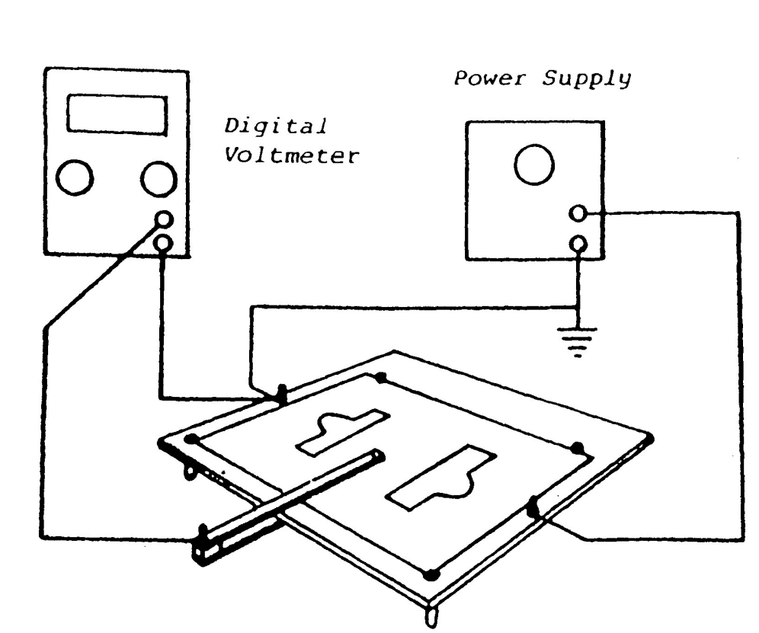

Figure : connection diagram for the Cenco Overbeck apparatus

The digital voltmeter is set to 20VDC. The U-shaped probe is placed so that the contactor makes contact with the plate on the underside. The probe is placed on the right conductor and the voltage on the power supply is adjusted until the meter reads 10V. A potential now exists with a continuous voltage gradient between conductors. The probe is moved until a point at 1V is found. This point is marked on the paper, and the point process is repeated along the equipotential line. This line is sketched by connecting the dots. This equipotential line process is repeated for voltages 3V, 5V, 7V and 9V.

Now the electric field lines can be implied by approximating the gradient on paper. These lines begin and end at contacts, cross all equipotential lines at right angles, point from higher to lower voltage and don’t cross other electric field lines. All conditions must be met for an accurate approximation. Four arbitrary points are selected by the instructor for the calculation of the electric field.

First, a common distance with maximum .5 cm is selected for . Next, the potentials at in the positive and negative directions are measured as and . Finally, Equation one is approximated using . The electric fields are then made for the two remaining plate patterns by repeating the same process.

The computer simulation aspect is completed in excel by first defining a sparse matrix. The only fixed values are the “conductors” set to 0V or 10V. Each element of the matrix is calculated using the relaxation method described by equation 2. In excel, this is accomplished by hitting the calculate sheet button. The number of iterations required to get to equilibrium is recorded.

# Results and Data:

The plate-plate sheet after calculating the electric field lines and 4 points.

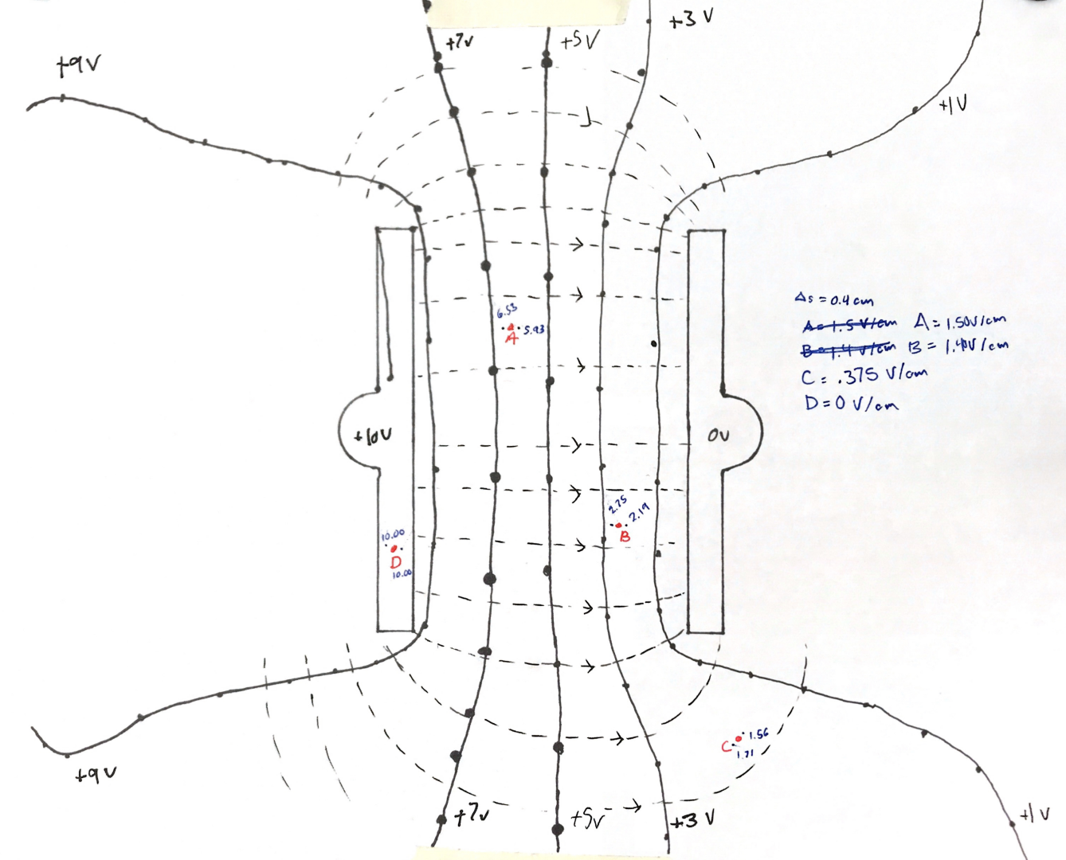

Figure 2 Plate Plate Geometry with 4 arbitrary points for Electric field Calculations

An example of the four-point electric field calculation is made using figure 2 and equation 1 with s = 0.4cm. It is important to recognize the direction of the electric field is pointing from higher potential to lower potential. Calculating takes a potential at one place and subtracts a potential in the opposite direction. For our calculations however, we are only interested in comparing the magnitudes of the electric field at 4 different points, so we will effectively remove the vector from the equation since its magnitude is 1.

The following table contains all points found in figure 2:

|  |  |
| --- | --- |
| Point | Electric field strength (V/cm) |
| A | 1.50 |
| B | 1.40 |
| C | .375 |
| D | 0 |

Table : Electric field strength calculations for each point in figure 1

This makes sense when we look at the location of the points. The electric field strength should decrease the further we get away from the source of potential. In between the two conductors, the field is the strongest and far away from the fields they are weaker. The fields have no strength within the conductor.

To be true scientists, we may want to find a way to quantify the similarity of the results of both methods. I believe this is not important because the result of this entire experiment is that the relaxation method “works” because our mathematical representations of electric fields are “good enough”. You only need to see the visual similarity of the equipotential lines to get it. The left side has real equipotential lines and the right panels are generated using math equations that have been used to describe electric field lines for a century.

All results can be compared below in figure 3: On the left, the solid black lines are the equipotential lines. These never cross. Perpendicular to these lines are dashed electric field lines. Those lines also never cross, although their requirements are more strict. They must point from higher to lower potential, start and end at each conductor and become more dense when the electric field is stronger. The figures on the right only contain equipotential lines from the simulation.

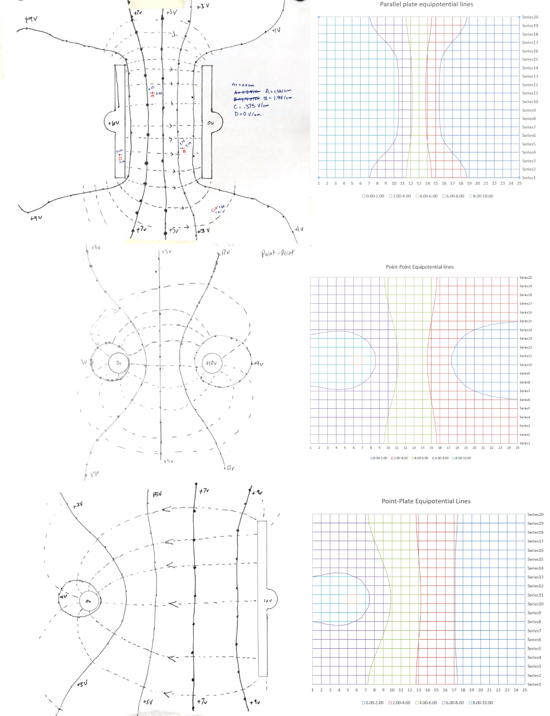

Figure Comparison of methods: the figures on the left are generated using the cenco overbeck apparatus and on the right are the same geometries but equipotential lines generated in excel using the relaxation method.

# Conclusion:

In our 4-point calculation of the electric field, we found that the field was strongest between the two conductors, weakest away from the conductors, and nonexistent on the conductors. This makes sense because conductors are not capable of creating a voltage differential, and electric fields tend to 0 the further you get from their source. Our simulation matches well with reality, although unfortunately, we were only capable of graphing the equipotential lines: vector fields are beyond the capabilities of excel. Additionally, since we are using a discrete grid and only one value can be calculated at a time, and the values depend on each other: the order of calculations might affect the results of the simulation. It is difficult to check though since our simulation has low resolving power, we did not exactly match up the plate patterns, and the physical equipotential lines are already approximated by visually connecting dots.

To compound the imbroglio, we have no quantitative way of assessing the discrepancy between reality and simulation. We can only rely on our eyes. Fortunately, the purpose of this lab is only to understand the significance of equation 1, not to perform realistic electric field modelling. And for that, our lab was a success.